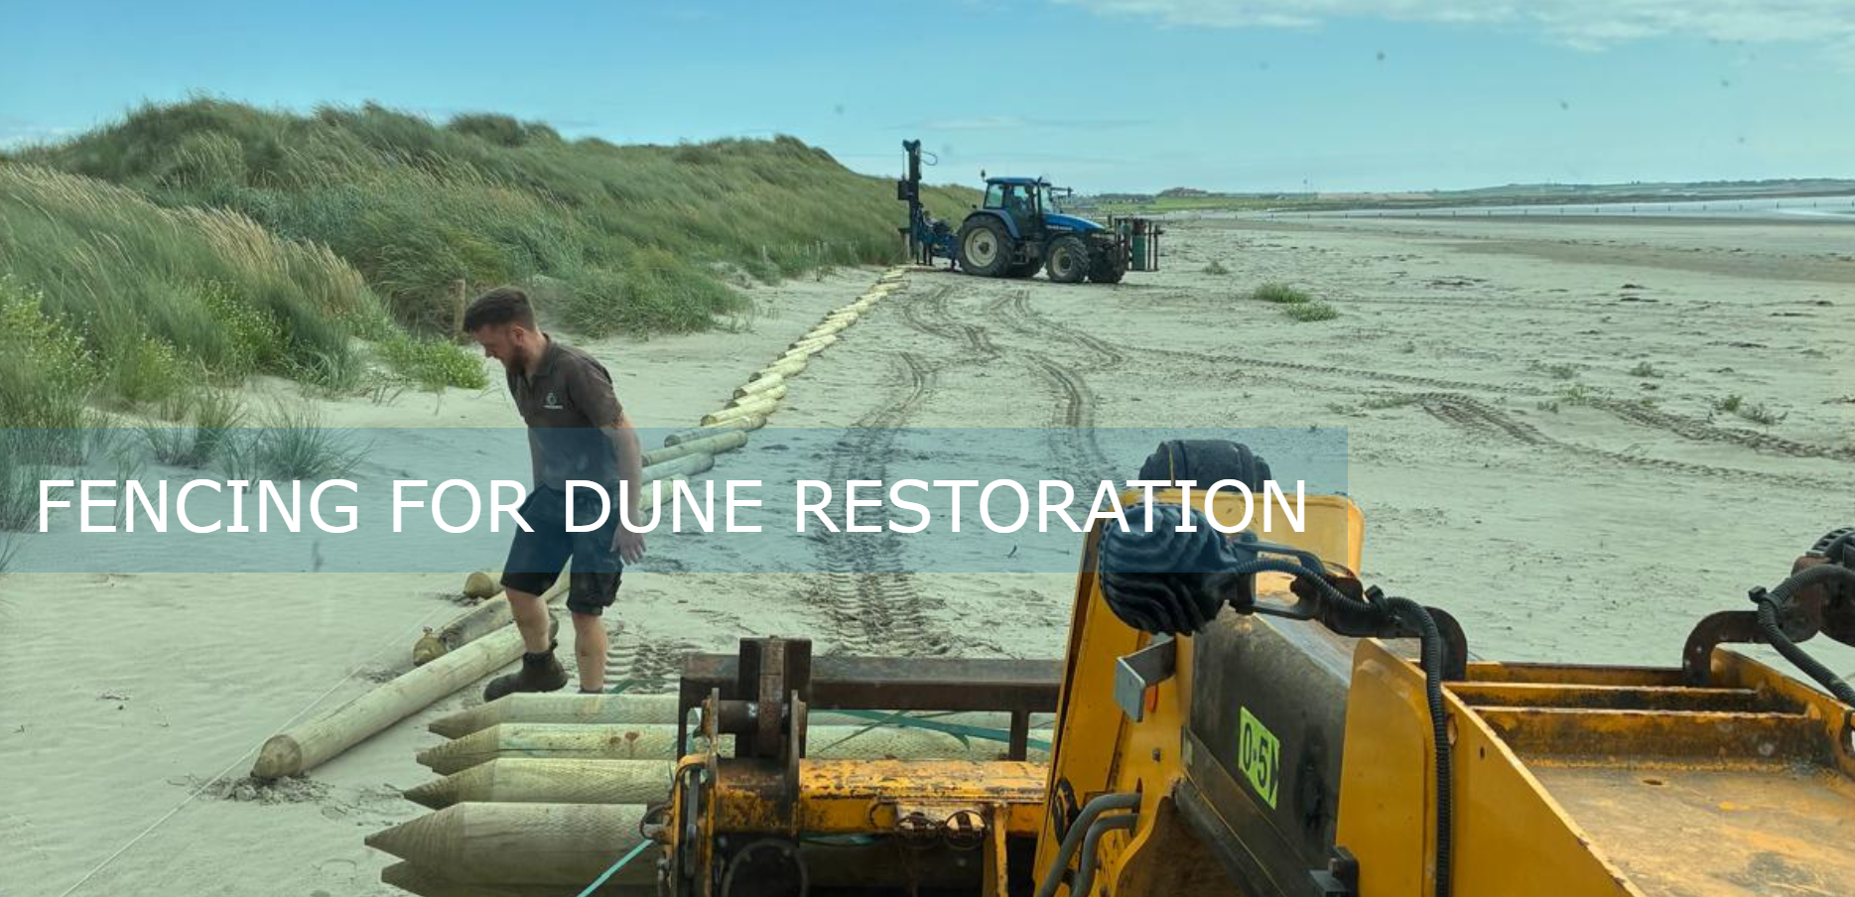

Cadwgan MacInnreactaigh August 2026 (0044) 07590462329 On behalf of Lecale Conservation cmacinnreactaigh01@qub.ac.uk

REAR FENCING AND PUBLIC NOTICES
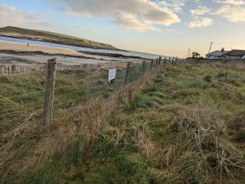.
The important first step in any dunes restoration is protecting the rear area of the dunes and directing leisure users to controlled beach entrances.
A standard non rust sheep fence with stayposts and a non-rust tensioning wire along the top is recommended and periodic heavy stay posts

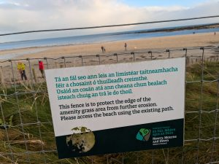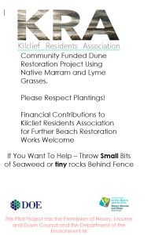

Public support is important for success. Explaining the reason for the fence will get 90% of beach users on board. If the local village association or residents’ group is involved it creates more support for the idea. At least 6 months pro-active maintenance is recommended as there will always be a minority that does not want to use the new beach entrances at first and repairs will need to be made.

PROTECTING GROWING FRONT EDGE OF DUNES
Depending on beach and its user base, two types of front edge fencing are possible.
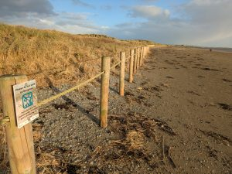
MINIMALIST. A cheap rope fence using lots of small notices to get the public on board. It is a good idea to ask the public to throw bits of seaweed over the rope or behind the fence as this does help trap sand and gives nutrient to new growth.

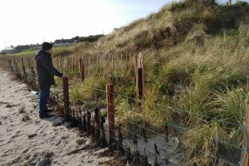
CONTROLLED. A sheep fence with rust-proof tension wire like the rear dune fencing like the example at the top of this page can be used to physically keep the public out of the dunes. But stronger and longer treated posts and stay posts should be used. Note the fence in this picture was shoulder-height – the level of the beach has risen 3 feet.
In front of palings. A ‘controlled’ or sheep fence at least 1 meter in front of sections of zig-zag palings is also essential as it allows for sand couch or Lyme grasses to build up dunes rapidly around the palings in the absence of human footfall. This allows sand to rapidly accumulate and ‘disappear’ the palings under tall new dunes.
PROTECTING NEW CONTROLLED ENTRANCES TO THE BEACH.
Were dozens of uncontrolled access points have been fenced off in favour of a few strategic entrances to protect a dune system, the new small number of entrances will be subject to a much higher level of footfall and may become weak points for erosion on the beach.
Using the approach below, they can be turned into giant beach strong-points for the beach.

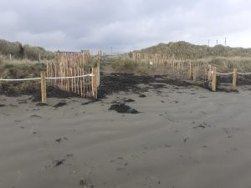
NEW ENTRANCE with zig-zag chestnut palings to create strong point in dunes in area of heaving human footfall. Simple rope fence in front of it to allow foredunes to grow

new entrance being armoured with chestnut palings
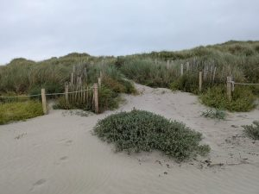
NEW ENTRANCE AFTER 7 MONTHS – with chestnut palings vanishing under new dunes

NEW ENTRANCE AFTER 1 YEAR chestnut palings vanished and new rope fence set forward of old one to allow even more foredunes to grow

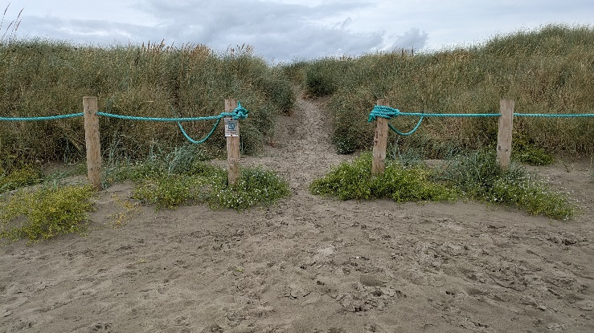

REPAIRING MAJOR BLOW-OUTS
The images below demonstrate how to repair a large blow-out following erosion triggered by large numbers of visitors to a beach where the front edge of the dunes and dune entrances are not protected or controlled.
Phase 1 – using palings (as per last section above) to protect both sides of blowout and to create a new ‘plug’ of 8 or 9 foot dunes around a zig-zag framework in the centre of the blow-out with sand couch grass and lyme grass in the centre.

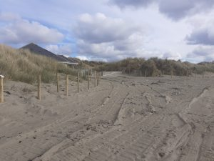
BEFORE Showing preparation for zig zag palings on both sides of blowout to stabilise old entrance. Giant central new dune also grown at centre. A less intrusive rope fence is then put in to keep the public off the newly regrowing front edge of the dunes.
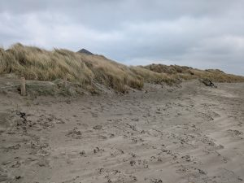
AFTER Palings buried by 8 to 10 foot new dunes.
a giant dune is grown in front centre of blowout as well as both sides of blowout armoured with palings.
These 3 giant dunes are then roped off and a new front edge created with additional plantings
The beach line is progressively moved forward towards the sea with additional rope fences to protect new plantings as dunes are ‘marched’ towards the sea

ARMOURING CONTROLLED ENTRANCES TO BEACH – using ‘zig-zag’ chestnut palings
Chestnut palings, properly installed in a zig-zag manner, create 8 foot tall storm resistant dunes within 18 months on any part of the beach. Those areas needing extra attention like controlled beach access areas are ideal for this method.
This approach turns the weak points in the dunes into strong points. Unprotected beach entrances can turn into giant blow-outs losing acres of dunes behind the front edge of the dunes. These blow-outs will also eat away the front edge of the sand dunes further in each direction with every high tide. 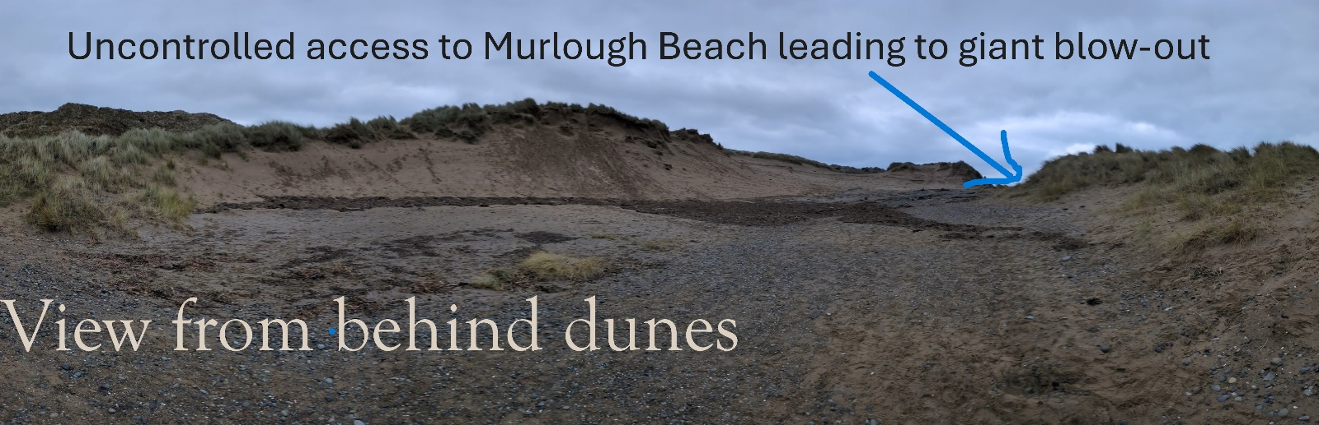
Here is a dramatic example of a blowout at the National Trust owned beach at Murlough in County Down. Here a failure to manage beach entrances and the front edge of the dunes is leading to massive losses compared to nearby Tyrella beach that has higher visitor numbers.

Difference in post-performance and price.
The posts we use are dipped for 16 weeks in preservatives to stop the rot ( same as the electricity poles).
They have a 25 years plus life time and are 2.3 meters long so can be pushed further into the ground. They are much stronger and are very unlikely to snap.
The posts on the left pass the Council’s ‘value for money test’ as they are about 1/3 the price but can snap in storms and be uprooted easily and rarely last the 5 years life expectancy in a salt environment.

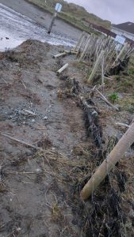
Cheap posts snapped off in first storm Our local Council uses 1.8 meters long posts which are copper sprayed and rated with a 5 years life span.
We have on several occasions had to get grant funding to replace these posts with sturdy agricultural posts that are more fit for purpose.

Never put chestnut palings in a straight line. Always use a 90 degree zig-zag!!
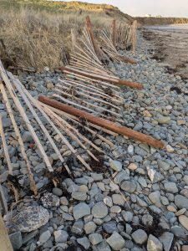
Multiple studies in North America show that if palings are placed in a recurring 90 degree zig-zag pattern, it slows the wind and grows dunes rapidly. Sand is trapped at x5 or x10 compared to a straight line.
They also better survive contact with heavy waves, storms and high tides, especially where the right type of posts are used (see ‘Protecting front edge of dunes’ above).

Heavy impact of waves and wind at high time or in storms. Purpose of the Zig-Zag Design
Putting palings in a line opposite the waves will result in them taking the full force of the sea in every wave at high tide or in storms. Often losing them along with any plantings in the first storm. As the line of the waves is not broken and the full force of the waves is felt going in and out, scouring with every wave.
More importantly, the sand collection effect shown in North American studies demonstrates that a X5 or X10 effect is created in extra “sand-drop” from the wind because of the aerodynamic effect of the zig-zag pattern.
The ideal wind effect works with a 90 degree zig-zag pattern with palings manufactured to 50% porosity. Palings in a single line will collect far less sand an essentially only function as a rather expensive fence for keeping the public off protected planning areas.
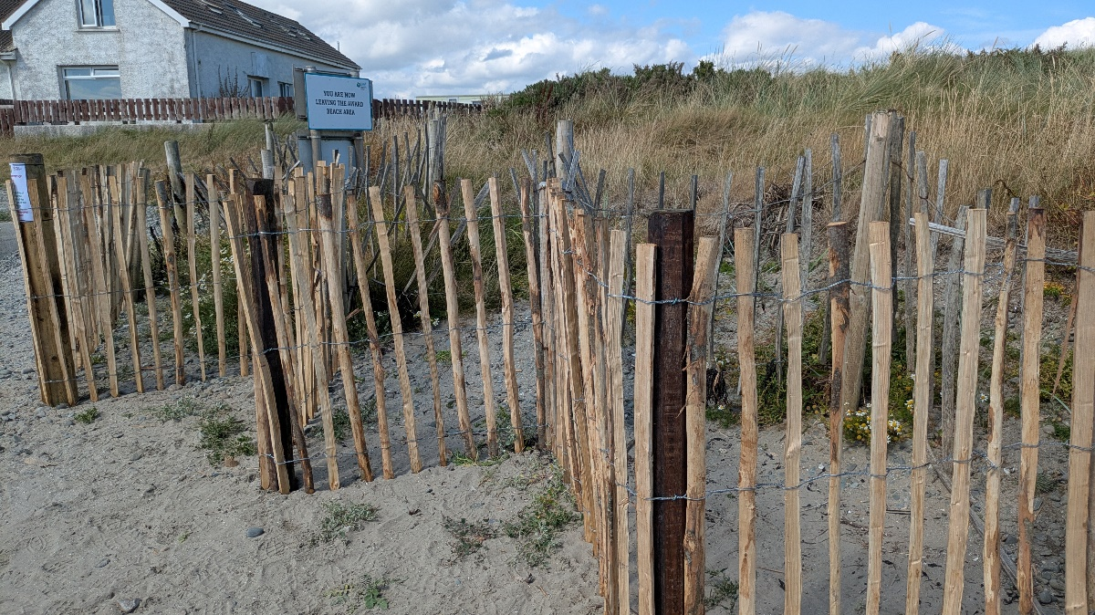

Marching New Dunes towards the sea

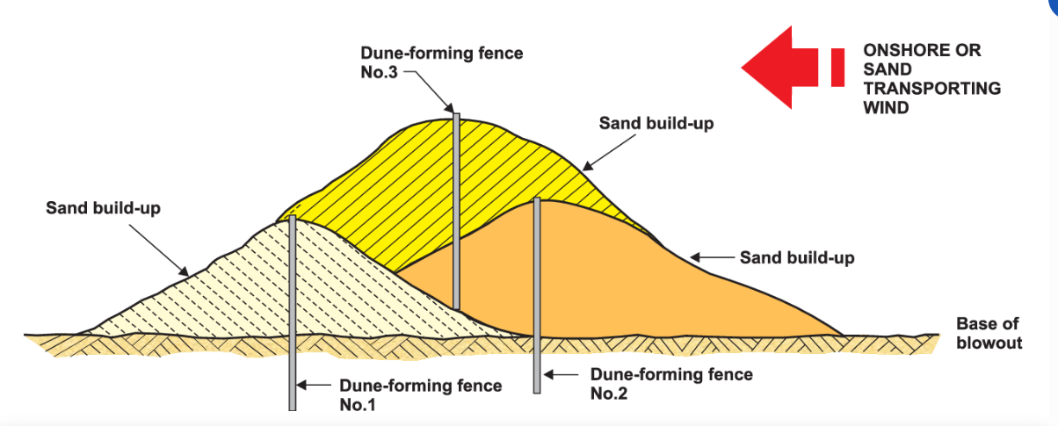
Successive layering of Chestnut palings will allow dunes to mimic their natural ‘march’ to the sea with the front edge protected. Increasing the sustainable height of the dune system over time.

Sand Trapping: The “zig-zag” (or “V” and “U” shapes) creates localized areas of low wind speed. When wind-blown sand hits these pockets, it loses energy and drops, building up a foredune.
- Erosion Control: By trapping sand, these fences fill gaps in dune ridges and protect fragile coastal ecosystems from being washed away.
- Energy Dissipation: Unlike straight fences, the zig-zag layout breaks up the direct flow of wind and water, preventing “tunnelling” effects that can accelerate erosion.
Installation Guidelines
  - Post Placement: Install treated chestnut posts at every “peak” and “valley” of the zig-zag (every change of direction).
  - Burial Depth: Posts should be at least 2 meters long, with at least 1 meter buried below the beach level to provide stability against shifting sand and wind pressure.
  - Porosity: Chestnut palings should have approximately 50% porosity (the gap between pales should equal the width of the pales themselves). This ratio is most effective for reducing wind speed without causing excessive turbulence.
  - Tensioning: The wire-bound palings must be pulled tight and stapled to the posts to prevent sagging or “bellowing” in the wind. 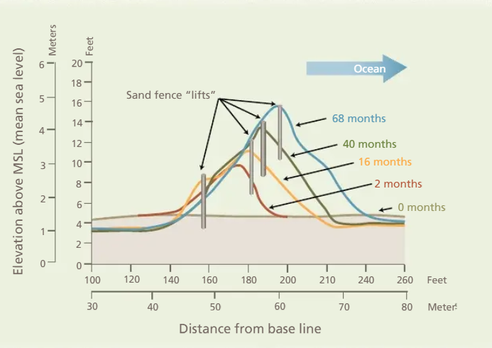
It is possible to estimate the time and investment needed to naturally restore a new front edge to sanddunes based on North American studies

SHOULD OLD FENCING BE REMOVED?
As can be seen from the photos and diagrams above. The idea behind zig-zag palings is that they should vanish under a core of permanent dunes that can be ‘marched’ towards the sea, or built into even higher dunes by successive layers. This has been done in coastal areas in N.America or the Netherlands where dunes of 30 meters in height are not uncommon. Removing this fencing would have to involve digging out the fencing and is likely to destroy this restored habitat.
On the other hand removing, maintaining or renovating the ‘low-impact front edge fencing’ or particularly the ‘rear fencing’ (see top) should be built into the maintenance regime of the land owner or beach manager organisation.
WHY IS HAVING A FIXED FRONT EDGE TO A DUNE SYSTEM IS A PROBLEM?
Marram grass will grow from the rear as the dune height increases. The marram will eventually overwhelm the other front edge plants as the dune gets higher.
These front layer plants had been growing at a lower height. The front layers of Lyme and Couch grasses or other ‘front growing’ species will want to grow forward too, until they meet human footfall.
At this point the foredunes will die. The result will be that the marram grass will now be growing at the front of the dune.
The front edge dune-growing species will have been squeezed out from both directions.
The result will be a tall marram-only dune, that is comparatively salt intolerant, facing onto the waves and high tide. This is a recipe for dunes being under-cut and collapsing into the tide. The diagram on the page below explains how to avoid this by ‘marching forward’. Link to this document is here
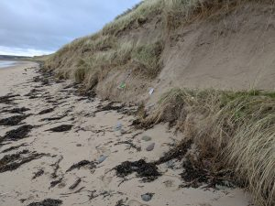
Typical situation across Ireland where the embryo and foredunes are lost to footfall leaving the less salt-tolerant marram dunes exposed.
This leaves the semi-permanent layer of marram dunes undercut and collapsing.

‘Marching’ the sanddunes to the sea. A policy of allowing the beach to slowly ‘march forward’ by a meter or so every few years and protect new front edge plantings or natural foredune growth would eliminate the need to remove old fencing as it would be covered by new inaccessible dunes as explained in the following diagram.
